**LAB 1 – HTML**

|  |
| --- |
| At the end of this lab, students should be able to:   * Create a simple webpage. * Use headings and paragraphs. * Insert images and hyperlinks. * Basic formatting. * Use lists. |

**Question 1**

Write the HTML codes to create the web page shown below.

* The web page title is “*Lab 1*”.

Heading level 3. Use <code> tag to get a special effect on the words.

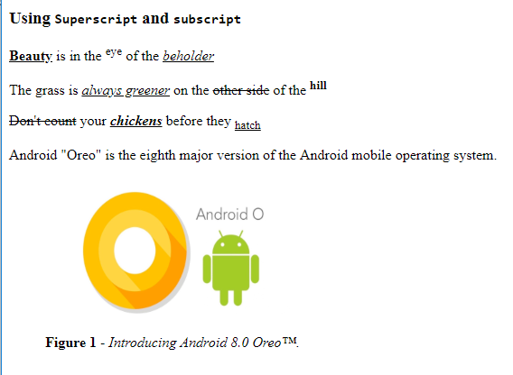

Image width is 300px and the height is 170px. Alternate text is “*Android Oreo 8.1.0*” and the tooltip text is ”*Android Oreo*”. There is a caption for the figure.

**Question 2**

Write the HTML codes to create the web page shown below.

* The web page title is “*My Travels*”.
* The hyperlinks URL are as follows(use unordered list):
  + http://www.balisunhotel.com/location/
  + http://www.balisunhotel.com/gallery/
  + For Contact Us, link it to the email address *contact@hotel.com*.
* The images width is 300px and the height is 200px. Both have tool tip and alternate text:
  + First image:
    - Tool tip: “*Pura Besakih*”.
    - Alternate text: “*Besakih Mother Temple*”.
  + Second image:
    - Tool tip: “*Ulun Danu Temple*”.
    - Alternate text: “*Temple By The Lake*”.

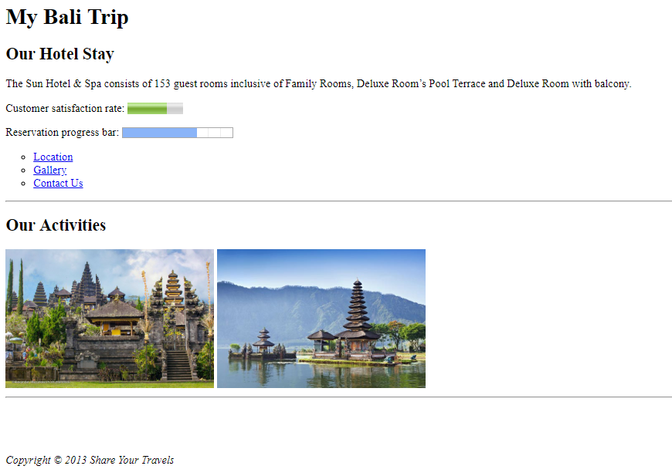

Meter value – 70%, Progress value- 68

Heading Level 2

Horizontal line

Heading Level 1

Heading Level 2

**Question 3**

Write the HTML codes to create the web page shown below.

* The web page title is “*Google Play*”.

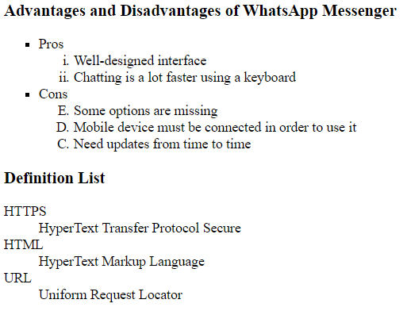

Heading Level 3

Heading Level 3